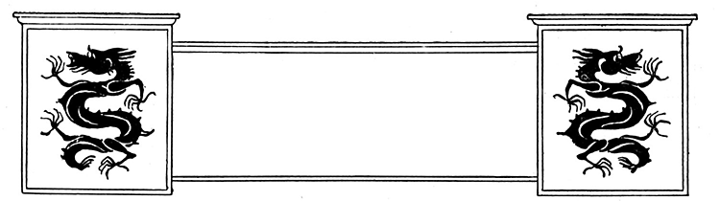
Station #1:

Xia and Shang Dynasties

With your group, read the information in your learning packet and answer the questions on page 58 of your spiral. You should also read pages 195-203 in the textbook to help support your answers. Be sure to use a sentence in response to each question.

You may share and discuss your answers.

Please reset the station as you found it for the next group!!

STATION #1
Reading Passage and Questions on the Xia and Shang Dynasties

We often hear of the word “dynasty” being mentioned when we hear something about China. What does it mean? Dynasty simply means a strong or powerful family that is able to maintain control over a country or region for a long period of time. There were many dynasties in China and several of them held control over China for many hundreds of years, passing down the control from father to son or uncle to nephew, etc.
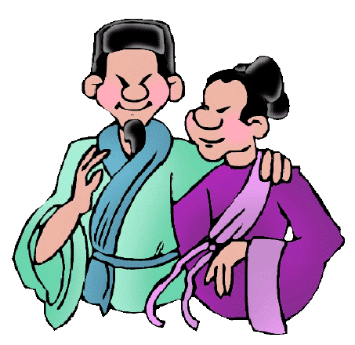
Archeologists have no records before the Shang dynasty (from 1500 B.C.E. to 1027 B.C.E.). This seems to be then the earliest recorded dynasty. Many remains have been discovered such as painted pottery pieces belonging to a group of people called the Yang-shao culture and another referred to as the Lung-shan. These two ancient cultures have no written record of leaders and government, but artifacts that have been found tell archeologists that they were probably farmers who planted crops and raised animals.

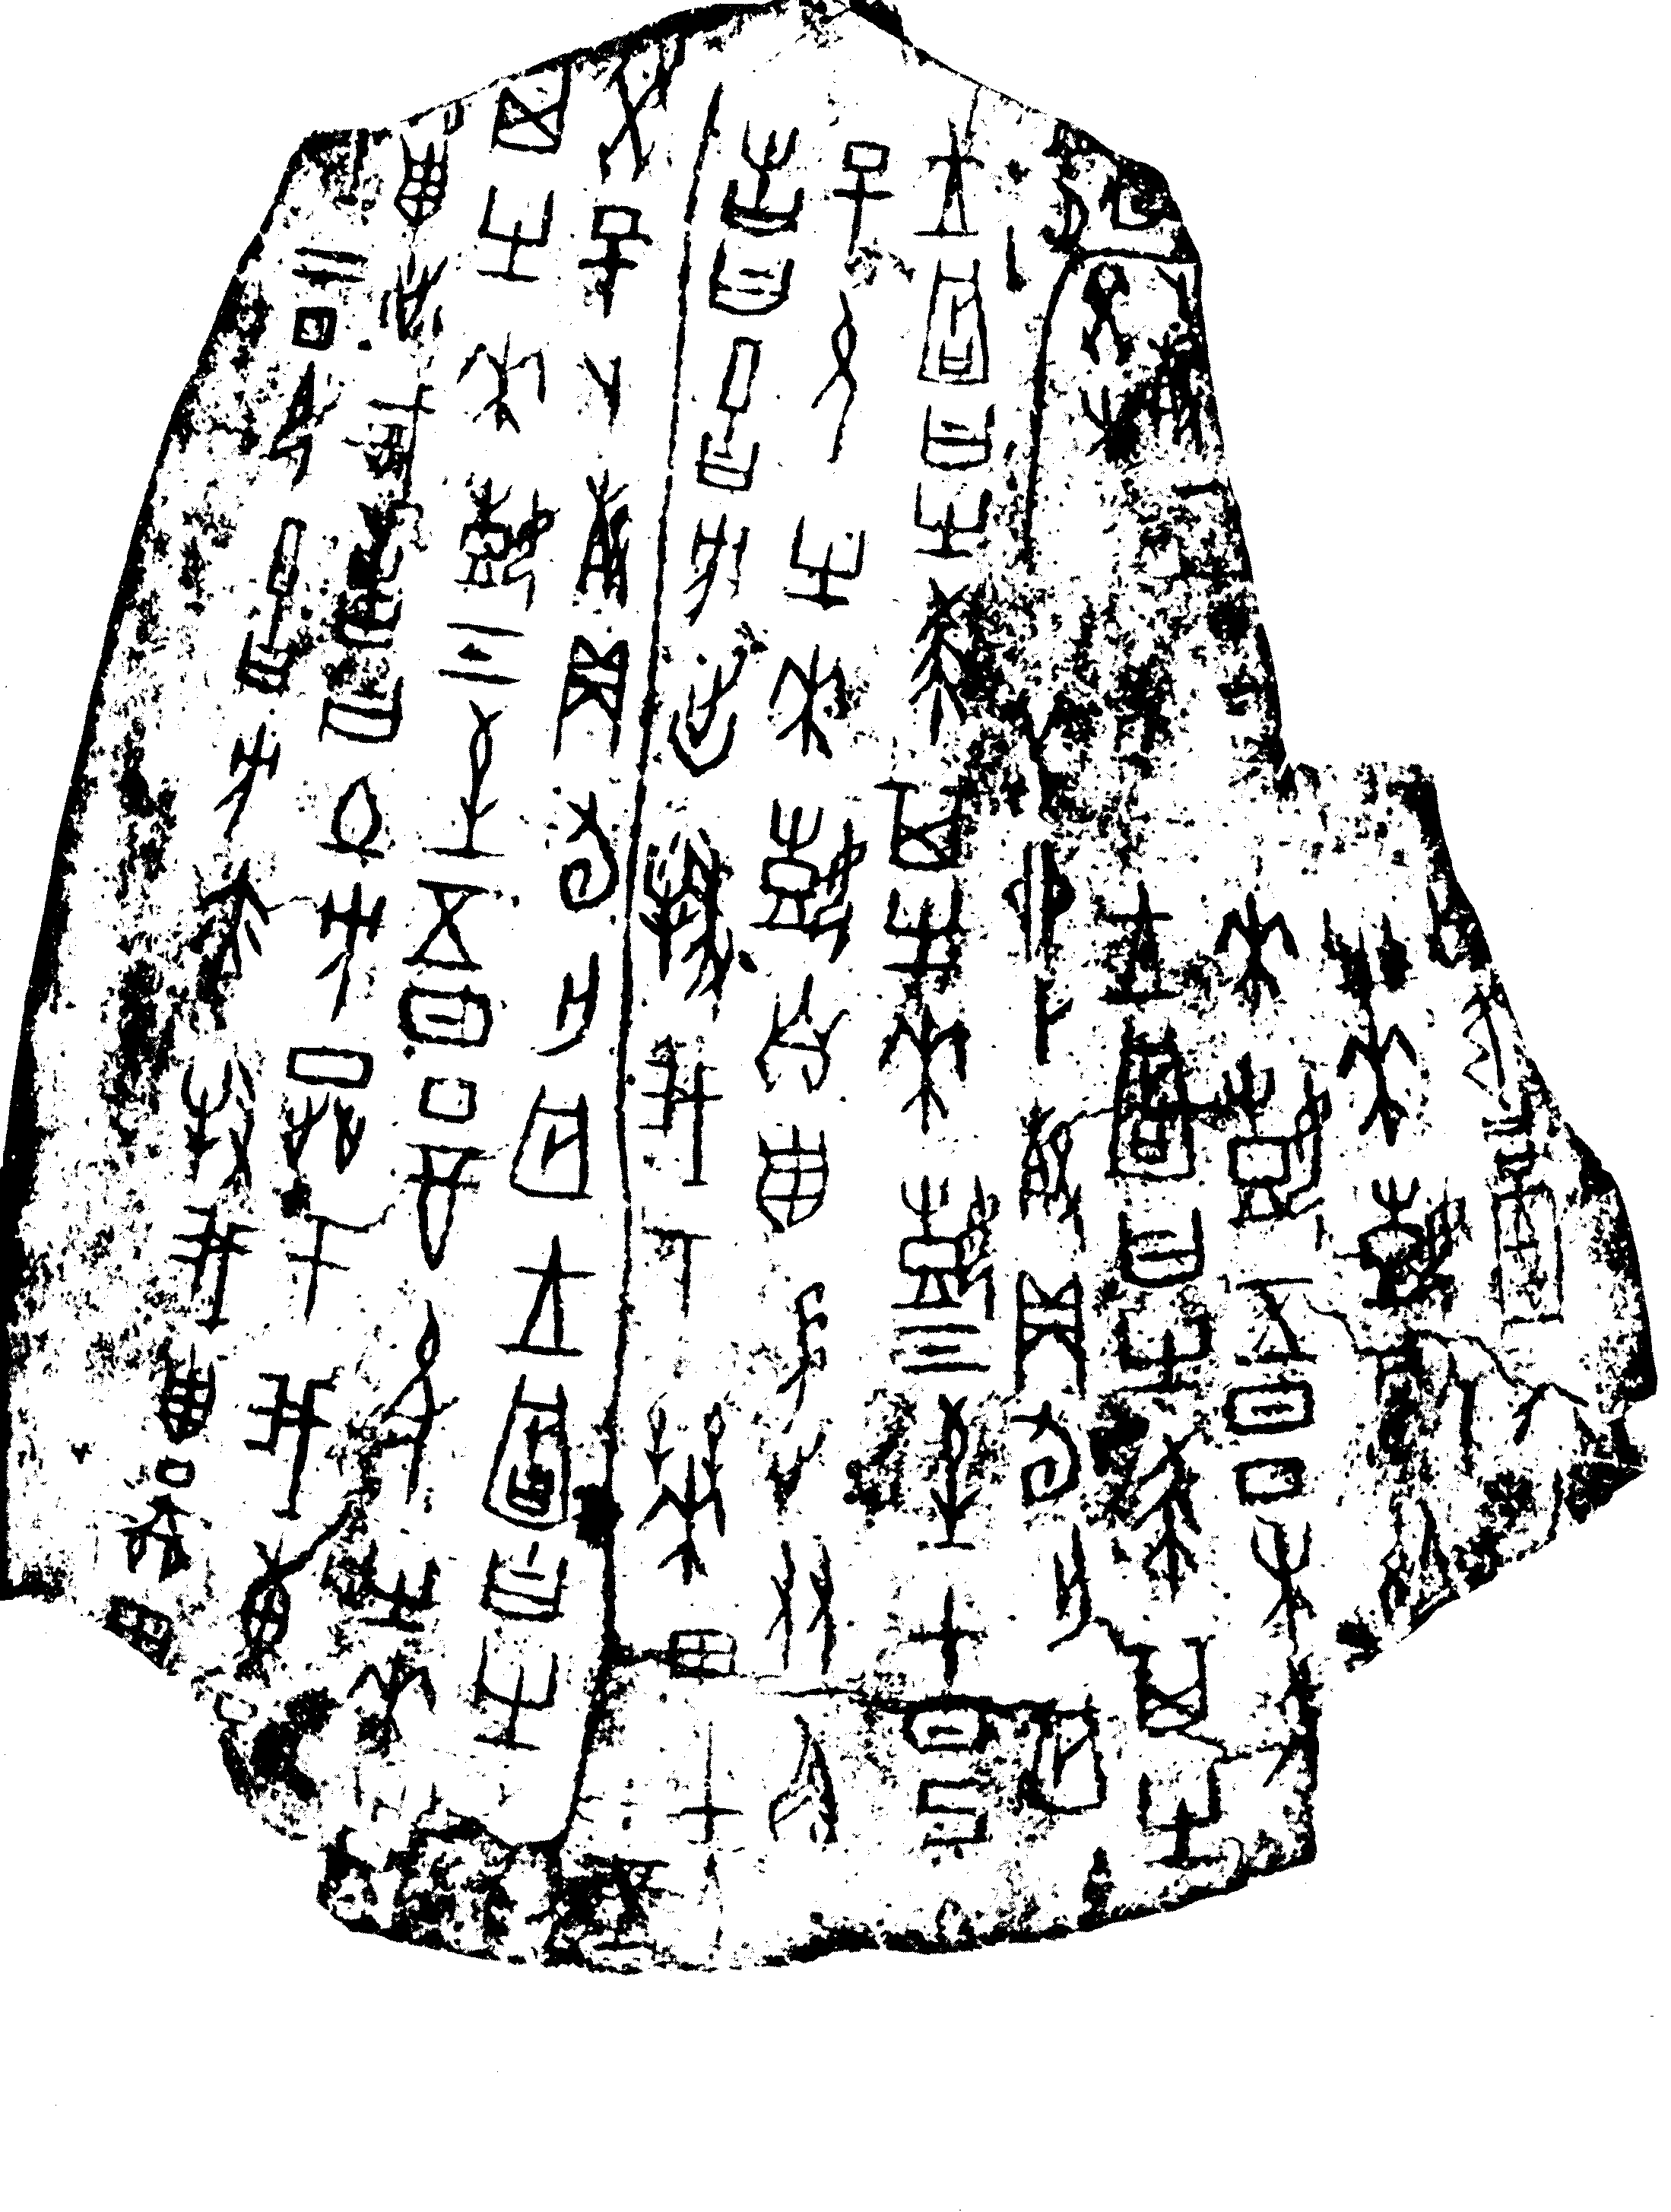
The Shang ruled a broad area of northern China and made many advances. The Shang created China’s first writing system. This system used more than 2,000 symbols to express words or ideas. Although the system has gone through changes over the years, the Chinese symbols used today are based on those of the Shang period. Shang writing has been found on thousands of cattle bones and turtle shells. Priests had carved questions about the future on bones or shells, which were then heated, causing them to crack. The priests believed they could “read” these cracks to predict the future. The bones were called oracle bones because and oracle is a prediction. In addition to writing, the Shang also made other achievements. Artisans made beautiful bronze containers for cooking and religious ceremonies. They also made axes, knives, and ornaments from jade, a hard gemstone. The military developed war chariots, powerful bows, and bronze body armor. Shang astrologers developed a calendar based on the cycles of the moon.

Before the Shang dynasty came to power in China, another dynasty, called the Xia, ruled but again there is no archeological record of this period of time, only stories handed down through the centuries. The stories told of the terrible floods. Archeologists and historians have not yet found evidence that the tales are true. However, the stories of Xia rulers were important to the ancient Chinese because they told of kings who helped people solve problems by working together. The stories also explained the geography that had such an impact on people’s lives.

Directions: Using the passage above answer the following questions. Be sure to go back and underline/highlight where you found your answer and write the question number in the margin.

- Define the word “dynasty”. Then use it in a sentence that shows clearly that you know the meaning of the word. __________________________________________________
__________________________________________________________________________________________________________________________________________
- What is the earliest recorded dynasty in China? ______________________________
- What does the use of oracle bones tells us about the early Chinese? _______________
_______________________________________________________________________________________________________________________________________________________________________________________________________________
- What advances were made during the Shang dynasty? __________________________
__________________________________________________________________________________________________________________________________________
- *Why do you think that “records” do not exist before 1500 B.C.E.? ________________
__________________________________________________________________________________________________________________________________________
- *How long ago is 1500 B.C.E.? (Think about how it would look on a timeline. Remember that B.C.E. means Before Common Era. This means it happens before year 0.) _____________

- * Give some reasons why different dynasties did not last for very long periods of time. _____________________________________________________________________________________________________________________________________________________________________________________________________

Station #2

The Zhou Dynasty

With your group, read the information in your learning packet and answer the questions on page 59 of your spiral. Be sure to use a sentence in response to each question. You may share and discuss your answers.

Once you are done filling out the worksheet, read pages 205-208 in the textbook and take addition notes.

Once you are done, read pages 205-208 in the textbook and take Cornell notes.

Please reset the station as you found it for the next group!!

Station #2:

The Zhou Dynasty
After the Shang dynasty was overthrown because its last leader was very cruel, the next dynasty was the Zhou dynasty (1027 B.C.E. to 771 B.C.E.). This dynasty lasted longer than any other dynasty in Chinese history. The Zhou dynasty made many changes to both religion and politics in China, and though it officially stopped ruling China in 771 B.C.E., it actually remained a ruling group within a smaller area until 256 B.C.E.

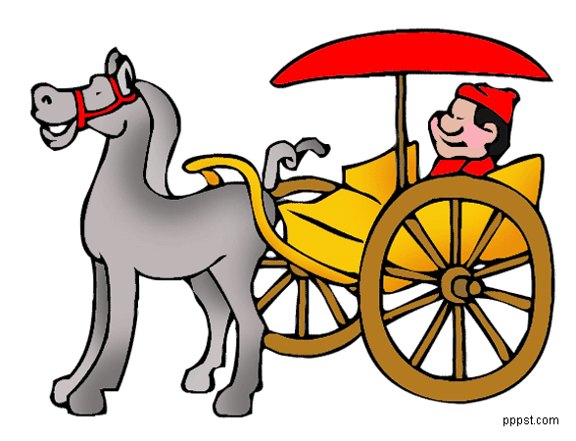
During the Zhou dynasty a system of communication was set up in order to send messages from town to town. Each of the different states in China had their own messengers, coachmen and station-masters located in each town. The distance that these messengers and coaches could travel greatly improved over the centuries.

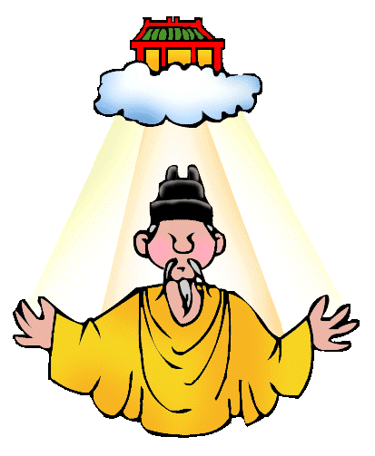
The Zhou dynasty established other Chinese traditions like the importance of family and social order. The Zhou kings claimed to possess the mandate of heaven. According to this idea, heaven gave power to the king or leader, and no one ruled without heaven’s permission. If a king was found to be bad, heaven would support another leader. Early Zhou rulers used the mandate of heaven to justify their rebellion against the Shang.

The Zhou established a new political order. They granted land to others in return for loyalty, military support, and other services. The Zhou king was at the highest level. He granted plots of land to Lords or people of high rank. Lords paid taxes to the king and provided warriors to protect his lands. Peasants, or farmers with small farms, were at the bottom of the order. Each peasant family received a small plot of land and had to farm additional land for the noble.

The Zhou Dynasty lost control of all China when many of the nobles decided they wished to rule their own particular areas. King Yu was killed and soon many independent states were set up within China. Unfortunately, these states over the next several hundred years often had very long and horrible wars between them.

Directions: Using the passage above answer the following questions. Be sure to go back and underline/highlight where you found your answer and write the question number in the margin.
The * indicates that it will be more difficult to find the answer in the text so try to find information that helps you and highlight those clues.

- Which dynasty lasted the longest? ______________________________________
- What does mandate of heaven mean? ______________________________________
_____________________________________________________________________
- How did the Zhou use the mandate of heaven to justify their overthrow of the Shang? __________________________________________________________________________________________________________________________________________
- Complete the following table that shows the structure and roles of each level of the Zhou Society

Zhou Political Order

KING
Jobs:

LORDS & WARRIORS
Jobs:

PEASANTS
Jobs:

- Define the Warring States Period: _____________________________________

____________________________________________________________________

Station #3

The Zhou Dynasty Philosophies

With your group,

Step #1: Copy the chart below onto page 60 of your spiral.

Step #2: Read pages 205-213 in the textbook
Step #3: Record information on the chart located on page 60 of your spiral.

Please reset the station as you found it for the next group!!
The Three Teachings & One Political system

The "Three Teachings" including Confucianism, Taoism, and Legalism were a great influence on the Chinese. Confucius (551-479 B.C.) taught people about the importance of being loyal, unselfish, and courteous. The roots of Daoism or Taoism go back to prehistoric times but were described around 600 B.C. by Lao Zi. He explained the "path" to contentment. Legalism goes back to the time of China’s troubles.

The Three Teachings & One Political System

Feudalism | Confucianism | Daoism or Taoism | Legalism

Station #4

The Qin Dynasty
Directions:
On page 61 of your spiral, recreate the following chart:

The Qin Dynasty

Five facts from Article | Five new facts from web site
1. | 1.
2. | 2.
3. | 3.
4. | 4.
5. | 5.

Using the Qin Dynasty article, write down five significant facts about Shi-Huang Di and the Qin Dynasty on the chart located on page 60 of your spiral.
Then read the article by Mr. Donn and write down five new facts that you learned about the Qin Dynasty on the chart located on page 60 of your spiral.

Please reset the station as you found it for the next group!!

The Qin Dynasty Article

The Qin Emperor’s Strong Government
The Warring States period marked a time in China when several states battled each other for power. One state, the Qin (chin), built a strong army that defeated armies of the other states. In 221 BC the Qin king Ying Zheng was able to unify China. He gave himself the title Shi Huangdi (Shee hwahng-dee), which means “first emperor.”
Shi Huangdi was a follower of Legalist beliefs. He created a strong government with strict laws and severe punishments. He ordered the burning of all books that did not agree with Legalism.
Shi Huangdi took land away from the lords. He divided China into 36 military districts. He made commoners work on government building projects.

A Unified China
Qin rule brought other major changes to China. Under Shi Huangdi, new policies and achievements united the Chinese people. The emperor set up a uniform system of law. Rules and punishments were to be the same in all parts of the empire. He also standardized the written language. People everywhere were required to write using the same set of symbols. People from different regions could now communicate with each other in writing. This gave them a sense of shared culture and a common identity.
Shi Huangdi also set up a new monetary system. Standardized gold and copper coins became the currency for all of China. Weights and measures were also standardized. With all these changes and the unified writing system, trade became much easier. A new network of highways connected the capital to every part of the empire. Workers built canals to connect the country’s rivers. Parts of the Qin irrigation system are still used today.
The completion of the Great Wall was a major Qin achievement. The Qin connected earlier pieces of the wall to form a long, unbroken structure that protected China from fierce northern nomads. Building the wall required years of labor from hundreds of thousands of soldiers and workers. Many of them died building the wall.
Although he unified China, many Chinese people hated Shi Huangdi’s harsh ways. When he dies in 210 BC, rebel forces formed across the country and tried to take over the government. The Qin palace was attacked and burned to the ground. Qin authority had disappeared. China fell into civil war.
Qin (Ch'in) Dynasty… by Mr. Donn Website
from http://china.mrdonn.org/qin.html
Many dynasties in Ancient China lasted for hundreds of years. But the Qin Dynasty lasted for only 15 years. Yet, First Emperor Qin accomplished an amazing amount of change.
Qin was the first man to control all of China. He did not want to be called a king. He called himself First Emperor Qin. He died of natural causes. But in the short time that he ruled China, he readied China to be pulled together as one country. But at what cost?
First Emperor Qin was a legalist. Legalists believe that people are basically bad. They believe that it is necessary to control and regulate every minute of people's lives so they have the discipline needed to work hard in the fields and in battle. Qin ran his dynasty with absolute control and swift harsh punishment. It was illegal to whine about Qin's government. If you simply suggested that things might be improved, you could be put to death without a trial.
Bureaucracy: To control his people, First Emperor Qin developed a system of bureaucracy. He divided his empire into 36 provinces. Each province was divided into districts. He put two government officials in charge of each province. It was their job to put strong people in charge of each district.
Workers were well trained and paid. They reported to supervisors. People at each level supervised those below them.

Spy System: To make sure everyone did their job correctly, First Emperor Qin set up a spy system. People had to spy on each other - it was the law. People had to spy on each other at work and at home in their neighborhood or village. If people turned in lawbreakers, they were rewarded. If they did not, they were executed. It was a simple system, and it worked very well.
This organization system gave Qin great power. That power allowed him to make huge changes. Qin knew that to unify China there had to be big changes. Most of his laws had something to do with protection.
Changes:
Land: First Emperor Qin took land away from the nobles. He did not want the nobles rising up against him. Anyone who argued with Qin was either buried alive or put to work building the Great Wall.
Standardization: He introduced one system of weights, measures, money, written language, and laws. Nobody argued with him.
Law Code: He introduced a new law code that applied to everybody. He created a huge law enforcement group, whose job was to enforce the laws.
Peasants: Peasants were assigned a job. They were either assigned the job of farmer or of silk maker. It they tried to do anything else besides their assigned job, they were sent to work on the Great Wall. If people were lazy or slow at doing their assigned job, they were sent to work on the wall.
Censorship: Qin practiced total censorship. He persecuted scholars and destroyed books. He defined useless books as any book about anything except books about medicine, agriculture, or prophecy. Useless books were burned. Over 400 scholars who refused to turn in books were either buried alive or sent to work on the wall. Qin did not believe in any education for the common man. According to Qin, the more time people spent studying, the less time they had to grow food. He especially disliked the teachings of Confucius. He had all Confucius' books burned.
Qin did not think his rule was cruel. He said, "A thousand may die so that a million may live." He built roads, canals, and bridges. His public works projects probably saved millions of lives that would have been lost to floods and famine. Although many people died building the Great Wall, it did provide an advantage in war.
No rebellion occurred during his rule. He died in 210 BCE. Once he was dead, his son took over. His son did not rule for long. People revolted again the Qin government all over the countryside.

The peasant who led that revolt became the new emperor. His dynasty was called the Han Dynasty. Life vastly improved during the Han Dynasty.

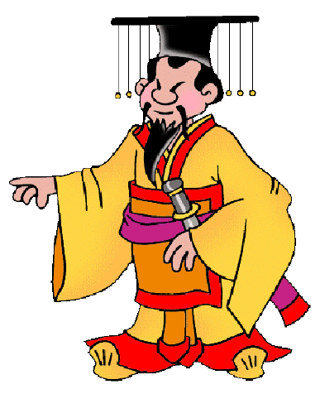

Station #4:

The Qin Dynasty

Five facts from Article | Five new facts from web site
1. | 1.
2. | 2.
3. | 3.
4. | 4.
5. | 5.

Draw a picture, with labels, of how you think the Great Wall was made and by whom. Your illustration must be colored.

Station #5

The Han Dynasty &
Chinese Achievements

Directions:

Step #1: Copy the kite into your spiral on page 62

Step #2: Sort each invention and match it to the description on the invention Card.

Step #3: In each section of the kite in your learning packet, list one achievement from the Han Dynasty. You must include one sentence describing the achievement, as well as an illustration. Your illustration must be in color!

Station #5:

The Han Dynasty and Inventions

1. Paper
Paper is one of the most wonderful inventions of China. Before the invention of paper people used to write on bamboo slips and silks. Tsai-lung (48-118 AD) an official of Imperial Court during the Eastern Han Dynasty was the creator of first paper in the world by drying pulp from bark, mulberry fibers, old rags and hemp. However according to a recent archeological discovery near Dunhuang, paper had been used for wrapping and padding in China since the 2nd century BC. They used paper as a writing medium by the 3rd century and by the 6th century they began using toilet-paper. Chinese were the first people to preserve the flavor of tea in square bags which were made from the folded and sewn paper during 618-907 AD, Tang Dynasty. The technique of paper making was slowly spread. It reached the Central Asia by 750 AD and Europe in the 14th century.

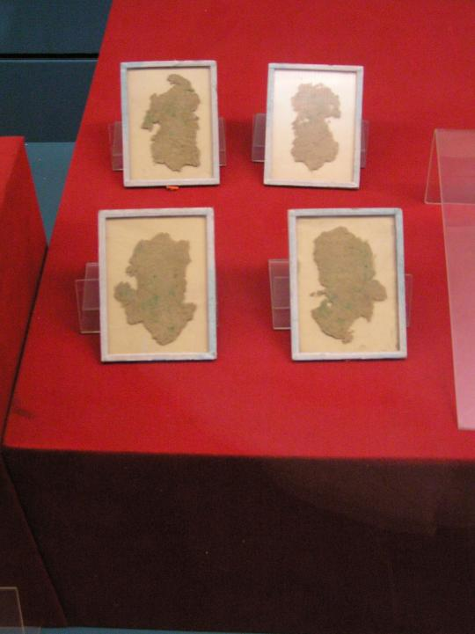

2. Printing

Chinese used printing pattern on the cloths before 220 AD. Woodblock printing on a paper is a process in which the individual sheets of paper were pressed into wooden blocks with the text and illustrations carved into them. This technique was first used by Koreans in 751 AD. he first movable type system (made of clay) was invented by Bi Sheng in China around 1040 AD. Later, movable wooden type was developed by Wang Zhen by the late 13th century.

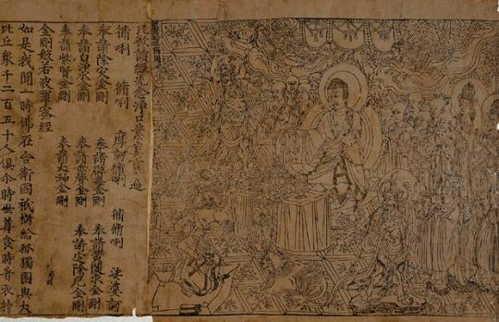

3. Gun Powder

Chinese were the first to recognize sulfur and saltpeter as essential ingredients for gun powder. Though many people wrote about the inflammable mixtures during 300-650 AD, some historians claim that the invention of gunpowder was dated at 850 AD. However the true gunpowder formula was first published in the history by Tseng Kung-Liang around 1040 AD.

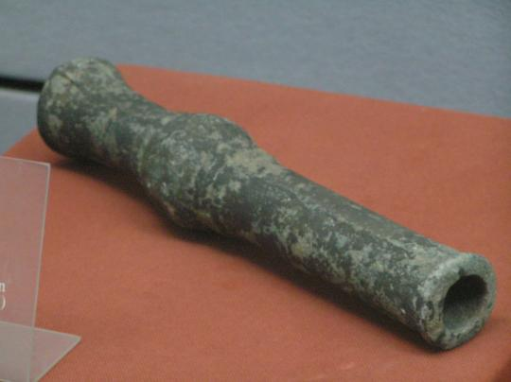

4. The Compass

The Compass was used by the Chinese during 1040-44 AD. They used this device as a direction finder to recognize the directions of north and south poles. The first compass was an iron fish pointing to the south, floating in a bowl of water. However, the compass that many used was in the form of a magnetic needle floating in a bowl of water.

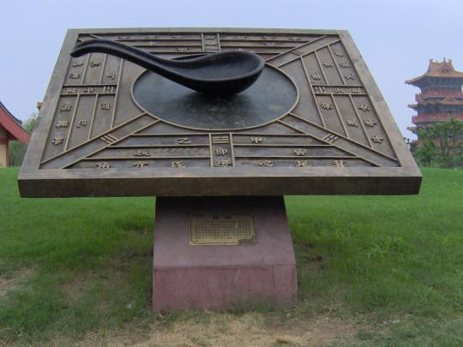

5. Seismometer

The first Seismometer was invented by Zhang Heng in 132. He was an astronomer and mathematician of the Han Dynasty (202 BC – 220 AD). The instrument is described as a large metal urn-shaped which used a suspended or inverted pendulum to study earthquakes. Zhang Heng also invented the Odometer and he was the first person to construct a rotating celestial globe.

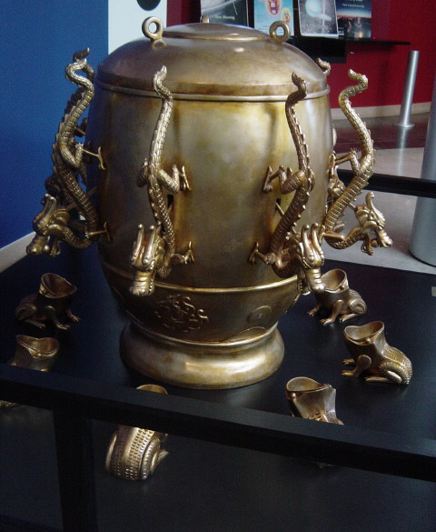

6. Cast Iron and Steel

According to the available archaeological sources, Cast iron (made from the melting iron) was developed by Chinese by the early 5th century BC during the Zhou Dynasty (1122-256 BC). Chinese were able to hold iron at high temperature for a week in 3rd century BC. Chinese developed the process of refining iron into steel in 2nd century BC. Interestingly they made a process named as “Hundred refining method” in which carbon is removed from the iron by injecting oxygen into the blast surface. They repeated this process many times, hence the name. The finished product from this process had excellent strength and can hold an edge on a sword. Chinese workers made different types of metals of modern times at that time.

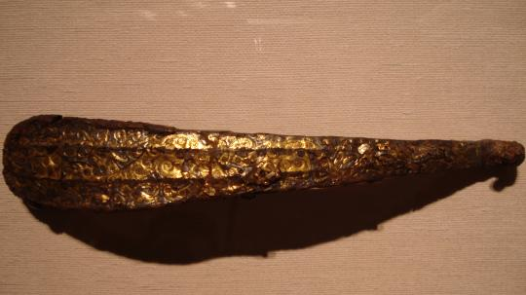

7. Winnowing Fan

Many people thought that rotary air conditioning fan was invented by Din Huan in 180 AD. But archaeological sources claim that rotary winnowing fan was made during the Han Dynasty (202 BC – 220 AD) for separating chaff from the grain.

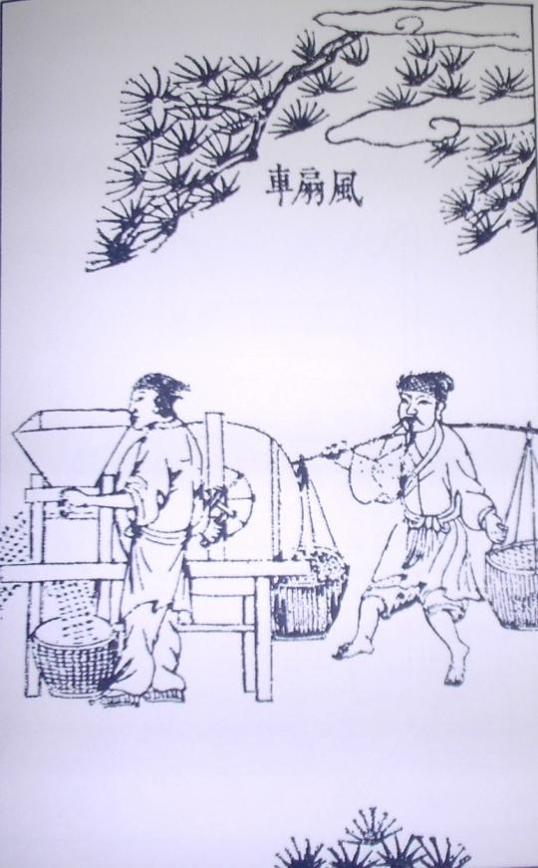

8. India Ink

India ink, a mixture of soot from pine smoke and lamp oil, mixed with the gelatin of donkey skin and musk, was invented by Tein-Lcheu, a Chinese philosopher in 2697 B.C., yet it became popular by around year 1200 B.C. It was designed for blacking the surfaces of raised stone-carved hieroglyphics.

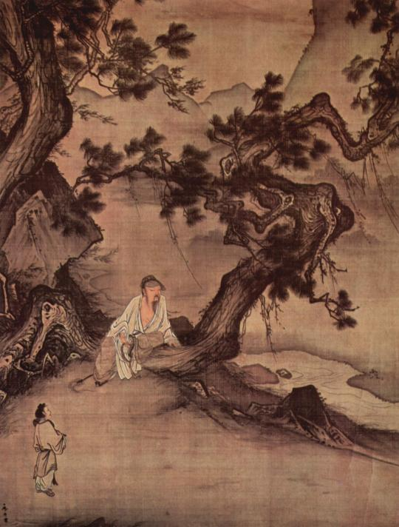

9. Matches

Chinese were the first people to invent the matches in the year 577 AD during the kingdom of Northern Ch’i. Early matches were made of sticks of pinewood with sulfur and the description was written by Ta’o Ku in the book “Records of the Unworldly and the Strange” in around 950 AD. However there is no evidence of using matches in Europe before 1350 AD.


10. Paper Currency

Paper currency was first developed in China during the Tang Dynasty (618-907) according to the wishes of merchants who would like to avoid the bulk usage of copper coins in large commercial transactions. The Central Government adopted this system during the Song Dynasty (960-1279 AD.

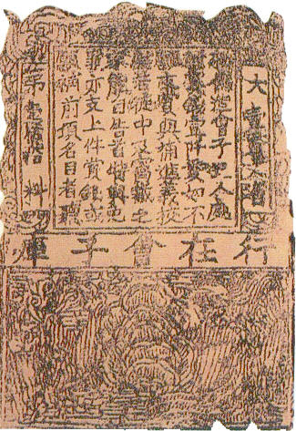
11. Suspension Bridge

The suspension bridge was invented by Chinese in as early as 1st century AD. Rope made from bamboo was first constructed in 300 AD on Min River. However there is documental evidence that an iron chain suspension bridge was built in Yunnan around 600 AD.

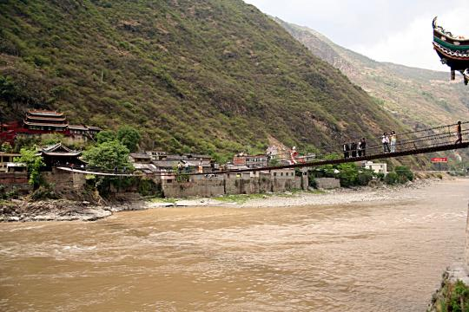

12. Umbrella

Umbrella was invented in ancient China in around 2nd century BC. Available sources suggested that collapsible umbrellas were designed with mechanical sliding levers during Han Dynasty (202 BC – 220 AD). Wang Mang, an official of Han Dynasty had designed a collapsible umbrella for a ceremonial four-wheeled carriage.

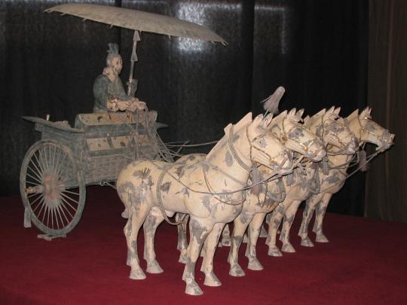

13. Silk

Silk was first developed in ancient China by 3000 BC. According to a legend, Leizu, Chinese Empress, wife of the Yellow Emperor of Chia, discovered silkworms spinning cocoons. She collected some cocoons and dropped a cocoon into the steaming water and amazed when a shining and soft thread started to separate itself from cocoon. Thus she invented silk loom in 28th century BC. Later Chinese used silk threads, silk belts and pieces of woven silk approximately in 2570 BC.

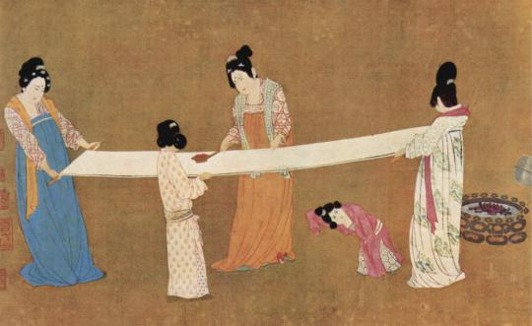

14. Chop Sticks and Forks

King Zhou of Shang was the first person to make the chopsticks out of ivory in the 11th century BC. Chopsticks made out of bronze that belonged to 1200 BC were found in the archaeological sources. According to the available sources bone forks had been used in China during 2400-1900 BC. This suggests that fork had been used in China long before chop sticks.

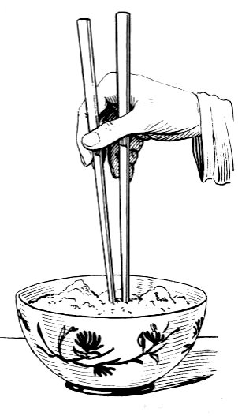

15. Porcelain

Though archaeological sources claim that porcelain was used in 3rd century AD, the true porcelain was made by Tao-Yue during 608 – 676 AD. He mixed white clay (found along the Yangzte River) to other types of clay which in result gave that white porcelain.

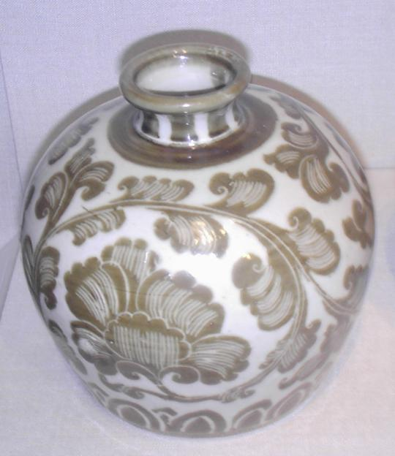

The Han Dynasty &
Chinese Achievements
Answer Key

