Interdependence/Resources/Specialization Flow Chart
Due at the beginning of the period tomorrow, Thursday, January 27
We've studied interdependence/resources/specialization in our study of economics using the Hersey candy bar as an example.
Now create a new pretend product using the interdependence model and include a flow chart. Select 3 countries as sources of a raw material needed for US manufacturing of the final product which could be sold both here and internationally. Show on your flow chart the countries and the raw materials using pictures and arrows to represent the flow of raw materials to finished product. Explain the steps of the process and how each item is connected! Make sure to use the following words: interdependence/specialization/resources
Examples of different types of flow charts:
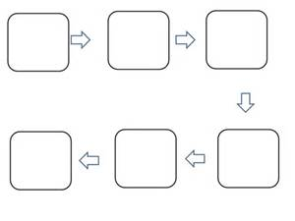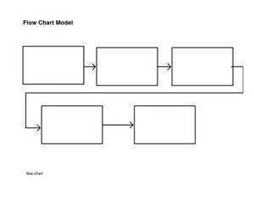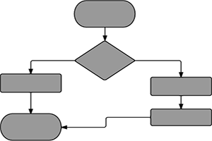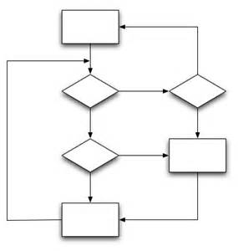

Interdependence/Resources/Specialization Flow Chart
Due at the beginning of the period tomorrow, Thursday, January 27
We've studied interdependence/resources/specialization in our study of economics using the Hersey candy bar as an example.
Now create a new pretend product using the interdependence model and include a flow chart. Select 3 countries as sources of a raw material needed for US manufacturing of the final product which could be sold both here and internationally. Show on your flow chart the countries and the raw materials using pictures and arrows to represent the flow of raw materials to finished product. Explain the steps of the process and how each item is connected! Make sure to use the following words: interdependence/specialization/resources
Examples of different types of flow charts:
