Personal Finance Assessment
Reminder, this is an assessment and that there is to be NO TALKING! Any students that is seen talking during the assessment, both their assessment, as well as the assessment of the student they are talking to will be taken and both students will receive a zero.This assessment will be due at the END of the period and that they may use your notes page, titled Personal Finance, which is on a piece of lined paper. YOU ARE NOT ALLOWED TO USE YOUR INTERNATIONAL TOWNE WORKBOOK!!!.

- The Supply Curve is upward-sloping because:
- As the price increases, so do costs.
- As the price increases, consumers demand less.
- As the price increases, suppliers can earn higher levels of profit or justify higher marginal costs to produce more.
- None of the Above

- Part of the reason that Peyton Manning earns millions of dollars each year while school teachers may earn $30,000 is because
- The supply of superstar quarterbacks is very low, while the supply of competent teachers is much larger.
- Demand for Peyton Manning talents is very high since he can generate so much revenue for a firm.
- Consumers enjoy football to the point that they are willing to spend lots of money and time attending games and watching commercials.
- All of the Above

- What is scarcity?

- Give an example of something that is scarce in your world? Explain why that item is scarce in your world.

- Based on what you choose for questions 4, how would you solve this economic problem using supply and demand.

- Where the supply line and the demand line intersect, indicates what?
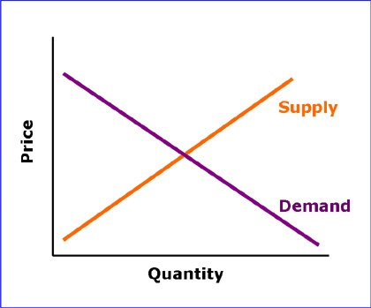

Situations: For the following situations, what would happen (increase/decrease):
- Because of a good rain season, what happens to strawberries…
Price__________________ Quantity__________________
- Because of advancements in electronic cars, what happens to oil…
Supply__________________ Demand__________________
- Because the Broncos win the Super Bowl, what happens to jerseys (think hard)…
Supply__________________ Demand__________________
- Because of the outbreak of the Zika Virus, what happens to international travel…
Price__________________ Quantity__________________

- Susannah went and hung out with her friends at the mall. Susannah could have practiced her violin or done her French homework. She thinks that if she hadn't gone to the mall, she would have done her French homework. Her opportunity cost for going to the mall is:
  - practicing her violin
  - doing her French homework
  - practicing her violin and doing her French homework
  - going to the mall.

- In one sentence, explain why people can’t have everything that they want?

- What is the equation to determine saving?
____________ -____________= savings
- Give 3 example of why people save?
- 2. 3.

- What does it mean to “Pay Yourself First”?

- Describe the relationship between Time and the Value of Money.

- How would you define interest?
Interest is a ________________ charged for ___________________ money.

- What would be the compound interest for $100 over 5 years at 10% (you are NOT allowed to use a calculator)…
Year | Amount | Interest Rate | Future Value
1 | 100 | 10%
2 |  | 10%
3 |  | 10%
4 |  | 10%
5 |  | 10%

- What is the opportunity cost of loaning money to a friend?
- You gain a new friend.
- You do not have that money to spend on something you want.
- Your friend pays off a debt
- a and b

- When decide what credit card to use, should you look for one with a high interest rate or a low interest rate, explain.

- What is the difference between a credit card vs.a debit card?

- Why is using a decision tree helpful?

- When looking for a saving account, do you want one with a high interest rate or a low interest rate? Explain why?

- Explain why we pay taxes

- List some goods and services that are paid with taxes

