The Legend of Rome
A legend is a story about a person who did something heroic. It is not based on fact nor can it be said to be the truth. Roman children were told the following legend about how the city of Rome was built.

Romulus and Remus
Romulus and Remus were twin brothers. Their father was Mars, the God of War, their mother was Rhea Silvia, a vestal virgin and daughter of the King, Numitor. Numitor's brother, Amulius, had taken the throne from him and had forced Rhea Silvia to become a vestal virgin so that she would not have any children who might try to take back the throne.
When the boys were born, Amulius seized them, put them into a basket and threw them into the river Tiber. He hoped that they would drown. However, the boys were rescued by a she-wolf who fed the babies with her own milk and cared for them.
They grew up and were found by the shepherd Faustulus, who took them home and looked after them until they were grown up.
This picture shows Romulus and Remus being found by the shepherd, Faustulus and his wife:
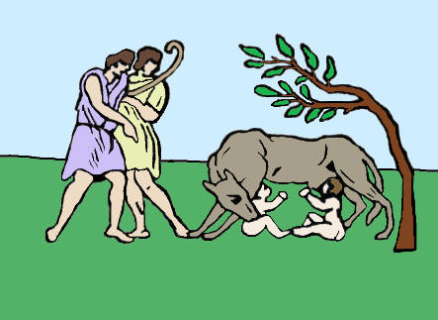
The two young men discovered who they really were and decided to kill Amulius and put their grandfather back on the throne. After doing this they decided to build a city of their own but could not agree where to build it. Remus favored the Aventine Hill but Romulus wanted to use the Palatine Hill. They could not reach an agreement and so each began to build his own city enclosed with walls.
One day, Remus visited Romulus and made fun of his wall by jumping over it and saying how easily it could be breached. Romulus was so annoyed that he killed Remus and said the he would kill anyone who mocked his city or tried to break through the walls of Rome.
The legend says that Romulus became the first King of Rome in 753BC and populated his new city with runaway slaves and convicted criminals. He stole women from the Sabine tribe to provide wives for the slaves and criminals and to populate his new city.
The Sabine tribe were not happy about this and declared war on Rome. The war went on for many years but eventually the Sabine tribe and Romulus reached an agreement and the Sabines became a part of Rome under the Kingship of Romulus.
The legend ends by telling how Romulus was carried up to the heavens by his father, Mars, and was worshipped as the God Quirinus.
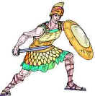
http://www.historyonthenet.com/lessons/legendofrome/story.htm

