Gladiator
by Mark Cartwright published on 06 November 2012
Definition: A gladiator was a professional fighter who specialized with particular weapons and fought before the public in large purpose-built arenas throughout the Roman Empire from 105 BCE to 404 CE (official contests). As fights were usually to the death, gladiators had a short life expectancy and so, although it was in some respects a glamorous profession, the majority of fighters were slaves, former slaves or condemned prisoners. Without doubt, gladiator spectacles were one of the most watched forms of popular entertainment in the Roman world.

The Great Entertainers
Roman gladiator games were an opportunity for Emperors and rich aristocrats to display their wealth to the populace, to commemorate military victories, mark visits from important officials, celebrate birthdays or simply to distract the populace from the political and economic problems of the day. The appeal to the public of the games was as bloody entertainment and the fascination which came from contests which were literally a matter of life and death. Hugely popular events were held in massive arenas throughout the Empire, with the Colosseum (or Flavian Amphitheatre) the biggest of them all. Thirty, forty or even fifty thousand spectators from all sections of Roman society flocked to be entertained by gory spectacles where wild and exotic animals were hunted, prisoners were executed, religious martyrs were thrown to the lions and the stars of the show, symbols of the Roman virtues of honor and courage, the gladiators, employed all their martial skills in a kill or be killed contest. It is a popular misconception that gladiators saluted their emperor at the beginning of each show with the line: Ave imperator, morituri te salutant! (Hail emperor, we who are about to die salute you!), whereas, in reality this line was said by prisoners about to be killed in the mock naval battles (naumachia), also held in the arenas on special occasions.
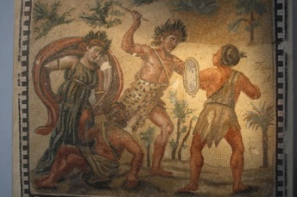
Gladiators most often came from a slave or criminal background but also many prisoners of war were forced to perform in the arenas. There were also cases of bankrupt aristocrats forced to earn a living by the sword. It is also of note that until their outlaw by Septimius Severus in 200 CE, women were permitted to fight as gladiators. There were special gladiator schools set up throughout the Empire. Agents scouted the empire for potential gladiators to meet the ever-increasing demand and fill the training schools which must have had a phenomenal turnover of fighters. Conditions in the schools were similar to any other prison, small cells and shackles for all, however, the food was better (e.g. fortifying barley) and trainees received the best possible medical attention; they were, after all, an expensive investment.

Weapons & Armour
Victors in the contests became darlings of the crowd and were particularly popular with women.
The term gladiator derives from the Latin gladiatores in reference to their principal weapon the gladius or short sword. However, there were a wide range of other weapons employed in gladiator contests. The gladiators also wore armour and their helmets, in particular, were objects of great workmanship, richly embossed with decorative motifs and set with ostrich or peacock plumed crests. Weapons and armour though depended on which class a gladiator belonged to. The type of weapons they had depended on the type of fighting they were going to do.
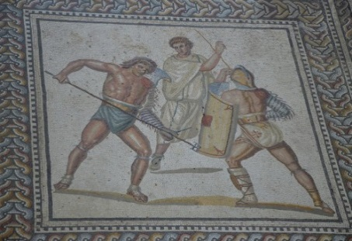
Winners & losers
Those who lacked enthusiasm to fight were persuaded by their manager and his team of slaves who carried leather whips or red-hot metal bars. No doubt the roars from 40,000 spectators and the unrelenting attacks of one’s opponent also convinced many to fight till the end. There were cases of refusal to fight: Perhaps one of the more famous was in the gladiator games organized by Quintus Aurelius Symmachus in c. 401 CE when the Germanic prisoners who were scheduled to fight decided instead to strangle each other in their cells rather than provide a spectacle for the Roman populace.
The losing gladiator, if not killed outright, often appealed for mercy by dropping his weapon and shield and raising a finger. His adversary could then decide to be lenient, although, as there was a significant risk of meeting again in the arena, it was considered good professional practice to kill your opponent. If the emperor were present then he would decide, although the crowd would certainly try to influence his judgement by waving cloths or gesturing with their hands - raised thumbs and shouts of Mitte! meant ‘let him go’, thumbs down (pollice verso) and Iugula! meant execute him.
Victors in the contests, particularly those with many fights behind them, became darlings of the crowd and as surviving graffiti on Roman buildings indicates, they were particularly popular with women. Graffiti from Pompeii gives a fascinating insight into how the gladiators were seen by the general public. More material rewards for winning one’s contest included the prestigious palm branch of victory, often a crown, a silver dish heaped with prize money and perhaps, after years of victories, even freedom.
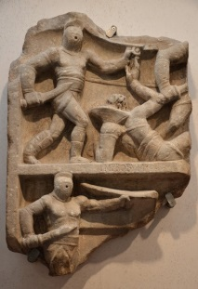
Decline in popularity
Gladiator contests, at odds with the new Christian-minded Empire, finally came to an end in 404 CE. Emperor Honorius had closed down the gladiator schools five years before and the final straw for the games came when a monk from Asia Minor, one Telemachus, leapt between two gladiators to stop the bloodshed and the indignant crowd stoned the monk to death. Honorius in consequence formally prohibited gladiatorial contests, although, condemned criminals continued the wild animal hunts for another century or so. Many Romans no doubt lamented the loss of a pastime that was such a part of the fabric of Roman life but the end of all things Roman was near.

