Feudalism vs the Manor System

The Middle Ages was an era that took place between the years 400 AD-1500 AD. You may wonder why this period is named the "Middle Ages", or the "Medieval Times", or even the "Dark Ages". This is a wonderful question that has a simple answer. The Middle Ages was a time that took place right after the fall of the Roman Empire and right before the prosperous period know as the Renaissance. The word "medieval" means "the middle" and Medieval life was a difficult transition time between the ancient world and the modern world; therefore, the middle period. Life was not easy during this time and many people endured very hard lives; with back breaking work, little food, and hope that keeping close to the church would send them to heaven at the end of it all. So the word medieval or dark ages accurately portrays the rough time that Europe was going through. Time was much different back then in comparison to nowadays. On this journey I will teach you of the beloved church, the system of government known as the feudalism, the simple daily life, and the role of women during this time period. Also note that the terms Middle Ages and Medieval Times are often used interchangeably. Please travel with me back in time to Europe, where the lands were governed by kings and queens, to gain knowledge about this difficult time in European history. Pack your bags and be prepared to enter a world unlike anything you've ever known!

The Manor System
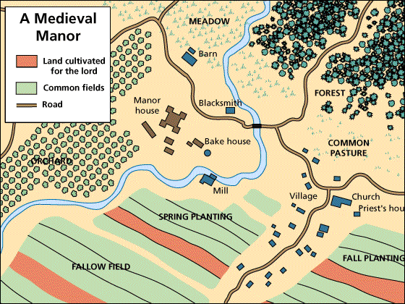

The manor system was a way that feudal lords organized their lands in order to produce agricultural goods. The manor had four main areas: the manor house and accompanying village, farmland, meadowland, and wasteland. The lord of the manor lived in the manor house and the serfs lived in mud brick cottages that were all in the same area. The serfs' cottages were very small and only consisted of one room. Serfs used fire to heat their homes when they weren't working in the fields. Serfs farmed and completed other jobs around the manor. Serfs also worshiped in the village church in attempt to go to heaven in their after life.
The manor system also used a special system to farm their fields. This system was called the three-field rotation. This system allowed each serf a strip of land. In the autumn one third was planted to wheat, barley, or rye, and in the spring another third of the land was planted to oats, barley, and legumes to be harvested in late summer. One strip was always left barren so that when the fields were rotated a strip of soil could be rested. Each of the strips were one acre of land and the best soil was given to the lord of the land while the serfs took to the rest of the farmland regardless of its quality. This system provided for the manor quite well, sometimes there was even a surplus. In times of surplus the serfs could sell their crops which allowed for towns and villages to grow

The Feudal System
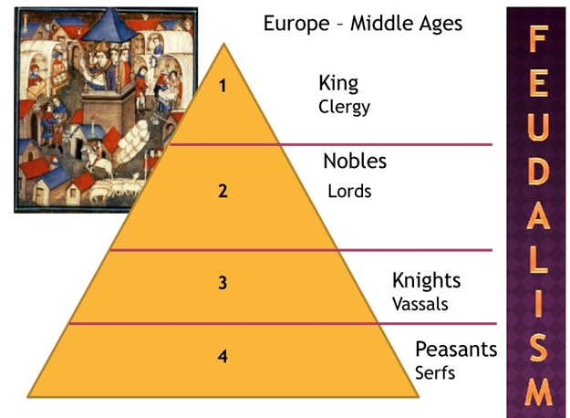

Today every civilized country has a form of central government that takes part in the ruling of the people of their land. During the Middle Ages there was an absence of a central government, therefore the people of Medieval Europe created their own government. The people saw a need for protection and justice. This government that the people created was called Feudalism. Feudalism provided protection for the townspeople. A characteristic that Feudalism held was the use of a social structure.

There were several levels found in the social structure. The first level was themonarch, king or queen, or clergy. The monarch was the highest level in the system and ruled over all of the land, except for the church. The monarch lived in a castle and governed over all of the manors in the land.

The next highest level in the medieval social structure was the lords, or nobles. The lords were given responsibility of estates by the monarch. In exchange for this land the lords gave the king their loyalty and military support. On their land the lords grew crops and were able to keep some of them for themselves. Also, the lords were able to keep the profit that was made from selling the crops. The lords of the manors were responsible for maintaining order of their land, enforcing the laws, and keeping the serfs safe.
Under the lords was the social class of the knights, or vassals. Knights were granted this title by the monarch of the land. Knights belonged to certain lords and fought for the lords during battles and wars. Knights wore a suit of armor made out of a pattern called chain mail (see picture). Chain mail was a covering made out of many, small interlinked metal chains. Knights were also known for using shields, lances, flails, maces ,and swords in battle. Their shields were decorated to represent who the knight was. Lances were long, strong, spear-like weapons designed for use on horseback. The mace was a spiked metal ball that was attached to the end of a wooden stick. Flails were like maces except the metal ball was attached to the wooden stick by a metal chain. Knights upheld a special code of conduct called chivalry. Chivalry stated that a true knight held these qualities: religious belief, bravery, loyalty, generosity, and strength. To be a knight in Medieval Europe was a major honor bestowed on only the best soldiers.

The lowliest level of the medieval social classes was the serfs or the peasants. Almost 90% of the population of Medieval Europe was serfs. Serfs were regular village people that worked the land of the manor. In return for protection and a place to live serfs were required to farm the land and perform other jobs that were requested by the lord. Serfs could be likened to slaves; they were forced to work the land of the manor and could not leave with permission from the lord of the land. However, unlike slaves serfs could not be bought, sold, or traded. Serfs held various jobs throughout the manor. These jobs included craftsmen, bakers, farmers, and tax collectors.

The poem below explains the life of a serf.

The Serf
I am a serf,
Weakest in the Land of Not.
I am a slave to all,
From the lowest serpent
To the loftiest dream.
I am a serf.
I and my kind stand like men,
But oft this is only an illusion.
Because we stand not together,
We stand not at all.
I am a serf.
I live blind, def, and dumb;
In ignorance and fear of the truth.
Not because I can't,
But because I won't have it any other way.
I am a serf,
Redeemable only because
I'm all that there is.
But for only as long,
As I'm all that there is.
I am a serf,
I and my kind are producers.
All things made,
Great and small,
Come from my ranks.

https://sites.google.com/site/lifeinthemiddleagesvft/home

