My Map of the Crusades Assignment
Use the map packet to complete the following assignment.

Make a Map!
Follow the directions below to complete the map on the opposite page. You will want to save this map as we will use it again later.
1. Label in light grey the Mediterranean Sea , the English Channel, and Atlantic Ocean.
2. Put a dot at and label in black the cities of Paris, London, Rome, Venice, Marseille, Constantinople, and Antioch.
3. In brown, label the islands of Crete, Cyprus, Corsica, and Sardinia.
4. In dark green, label the Christian kingdoms of England, France, Sicily, Scotland, Castile, Argon, Portugal, and the Holy Roman and Byzantine Empires.
5. In dark purple, label the Muslim Dominions of Saladin, Almohads, and the Seljuk Turks.
6. Lightly shade all Christian lands in green.
7. Lightly shade all Muslim lands in purple.
8. Put a blue star at and label the city of Jerusalem.
9. Use red to make a symbol that represents a battle and put it at and label the city of Acre.
10. Draw and label the paths taken by King Richard the Lionhearted and King Phillip Augustus to Acre.

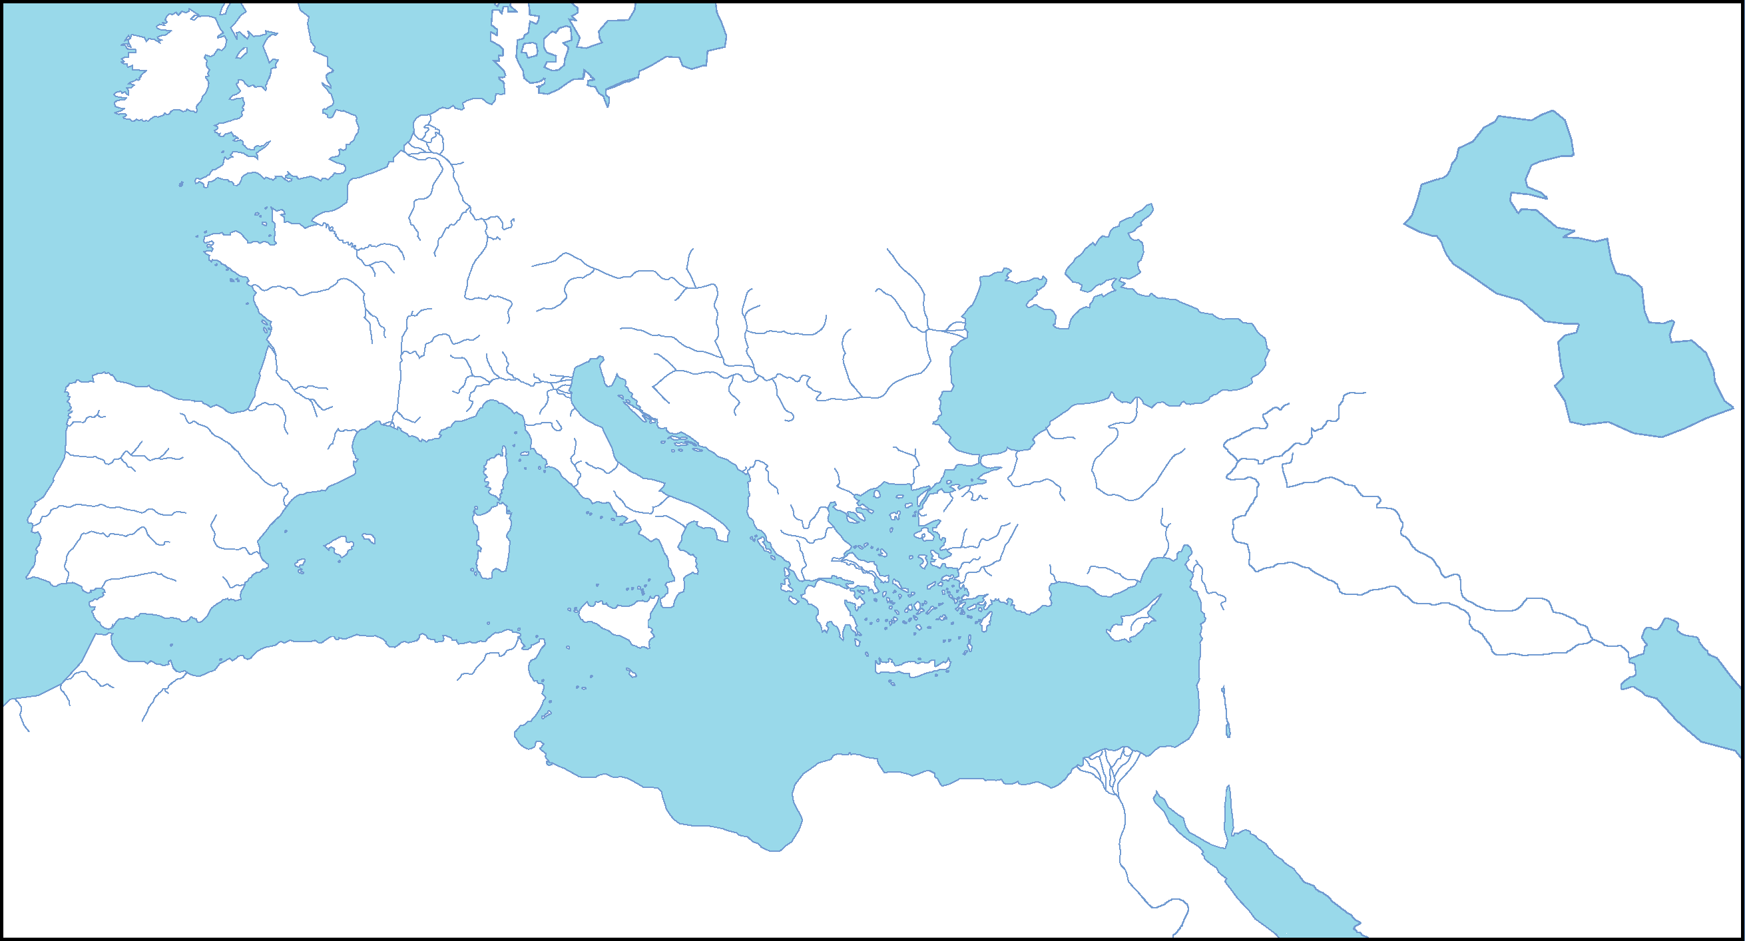
My Map of the Crusades
Interpreting the Maps!
Use the maps provided to answer the questions below on page 96 of your spiral.
1. The men (and they were almost all men) who answered the Pope’s call to take back the Holy Land were called Crusaders. From which parts of Europe did most of these Crusaders come from?
2. Which city appears to be the focus of the Crusaders’ efforts? Which Crusade did not make it there?
3. How many years separated the First and the Fourth Crusades?
4. Which Crusade was the most successful? How do you know?
5. The Book of the Lion is about the Third Crusade. This one is often called the Kings’ Crusade because of the European kings who went. According to the map, who were the three European Kings who participated in the Third Crusade?
6. The area around the Jerusalem is often called the Holy Land. Who controlled the Holy Land at the time of the Third Crusade? Were those people Christian or Muslim?
7. How are the routes the different kings took to the Holy Land different from each other? Who do you think took the longest to get there? Why? (Hint: One king died before reaching the Holy Land. Don’t count him)
8. About how far is the journey from England to Acre by way of Italy? How far by the way that King Richard traveled?
9. Looking at the information from the maps, does it look like the Crusades were a pilgrimage (a journey to a holy or sacred place) or a holy war (a war fought by believers of a religion to spread or defend their religion)? Write a paragraph stating your opinion, your reasons, and facts from the maps them.

file:///C:/Users/mlaw/Downloads/The%20Crusades%20Map%20Assignment.pdf

